# Build Expo Apps

Sign up at <https://expo.dev/signup> to create expo account. Use Free Plan (Default member)

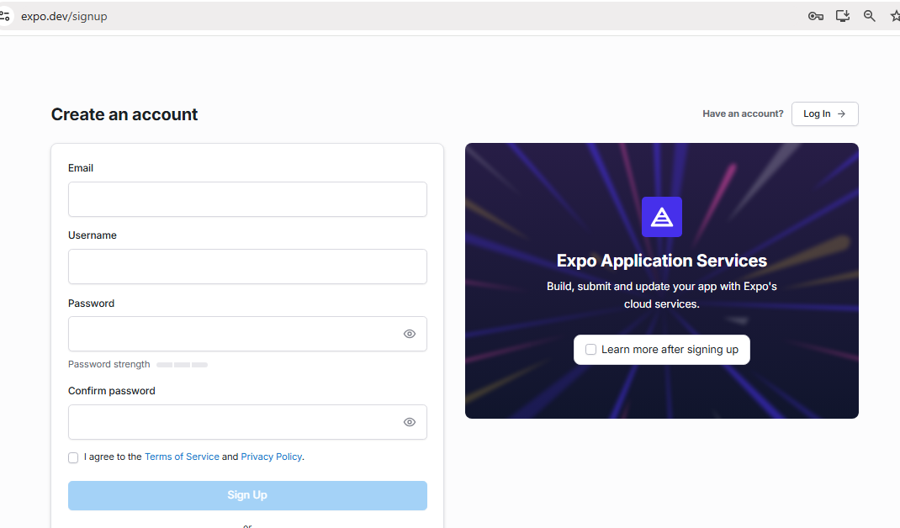

Check your build usage.   
For now, the limit for building Android apps is 30 times in 1 month, and 15 times for iOS apps in 1 month.

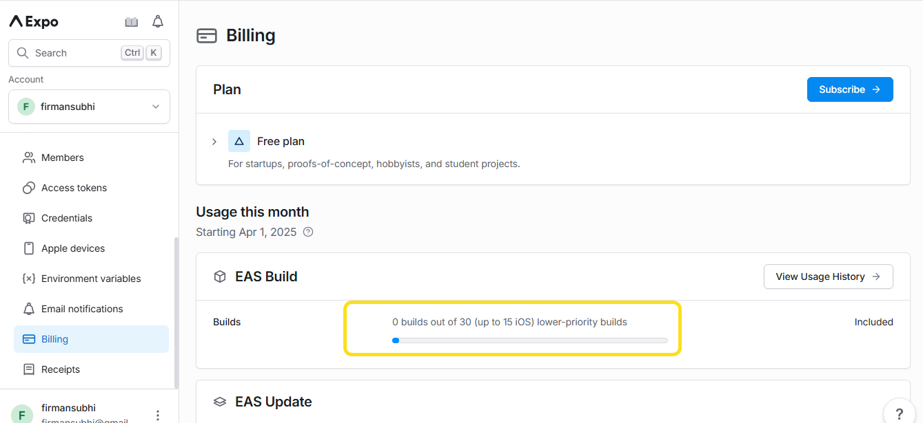

Open your project with VS code and run this command in terminal to update all package

To update npm:  
**npm install -g npm@latest**

to update expo:  
**npx expo install expo@latest**

to adjust the package version to match the latest expo version  
**npx expo install –fix**

Make sure your apps can run properly. If so, you can close your apps.

install the latest EAS CLI  
**npm install -g eas-cli**

Log in to your Expo account in terminal with your expo account  
**eas login**

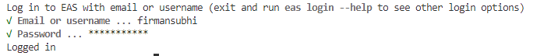

Select **Yes** / **Y** if a question appears to create a project automatically.

because i only use android devices, then i will choose Android

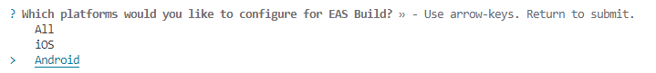

If successful, a new project will appear in our expo account.

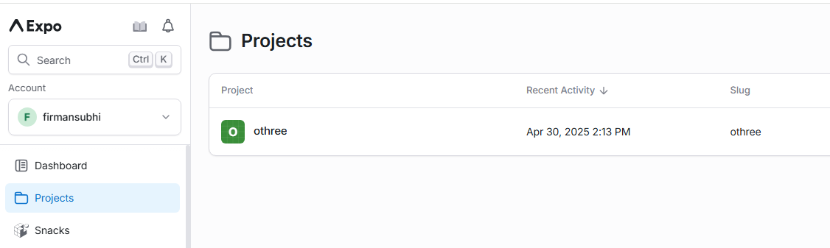

I don't have a developer account for Play Store or App Store. So I can only build for testing.

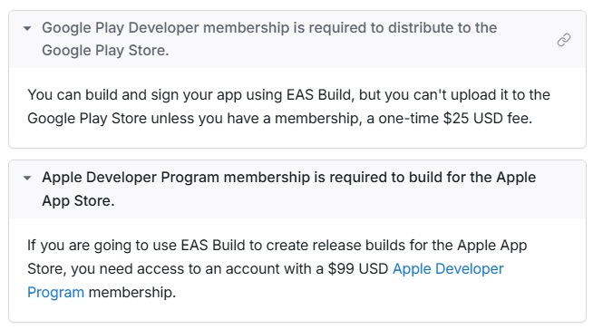

i only have android device. so i use tutorial from here

<https://docs.expo.dev/build-reference/apk/>

if you are using an iphone, you can follow this tutorial for iOS SImulator

<https://docs.expo.dev/build-reference/simulators/>

**Create APK file for android**

Modify your **eas.json**   
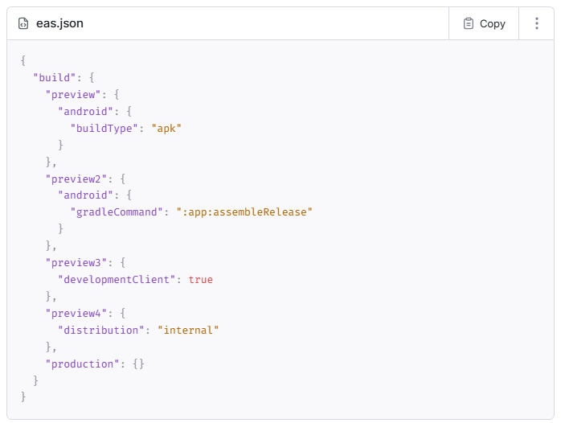

Now you can run your build with the following command:  
**eas build -p android --profile preview**

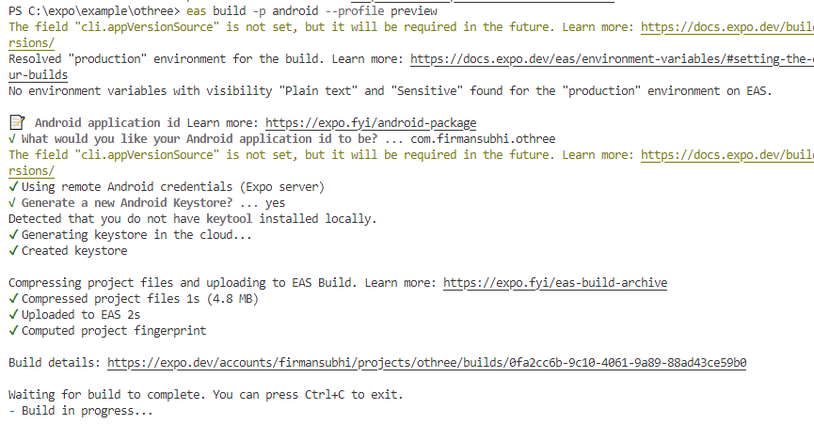

Open your project in Expo Website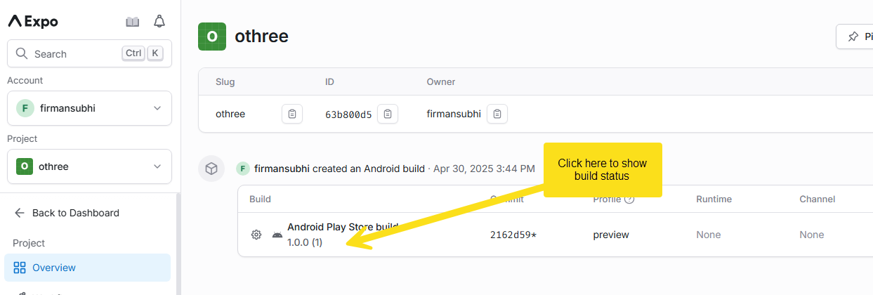

This process takes quite a long time, it can take up to 20 minutes. Once it is finished, you can download the apk file and install it to your android devices.

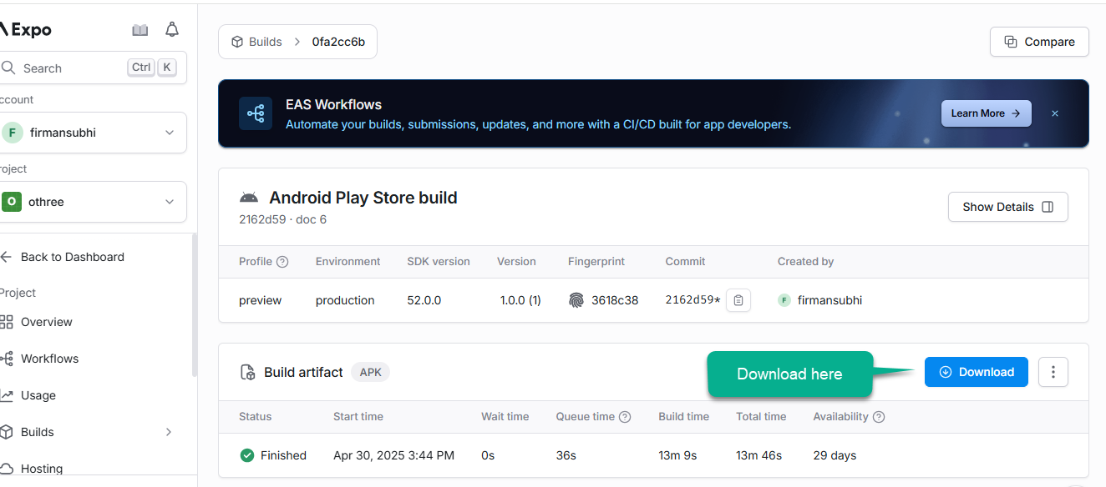

To submit an application to the Play Store/App Store, you can click the submit button, then follow the instructions given.

